**CSCI572 Homework 4 Report**

**Name: Shurui Liu, 9999-9586-70**

**Spell Correction**

Code: **SpellCorrector.php**

I downloaded this file from Norvig website and made some changes. I added an array that contains all the common stop words that have no use in **SpellCorrector.php**. So when this PHP file runs, the correction function will not include these common stop words.

**AutoComplete**

Code: **Solr suggest component**

In this part, we are asked to use the auto suggest component comes with Solr, which is the FuzzyLookupFactory. I made appropriate changes in this part of the code so that when I type in some words, the query will be separated by Solr by space, then return me some suggestions from the JS code.

**Snippet**

Code: **simple_html_dom.php**

In this part, I write a simple PHP code that can parse all the HTML files. I generate the snippet by finding the searched word and added about ten words in front of the keyword and ten other words after the keyword. So the whole snippet is like

***Xxxxxx (10 words in the front) + keyword + xxxxxx (10 words after the keyword)***

**Analysis of Result**

1. Five examples of misspelled words. The examples also show what happens after clicking on the suggested link.

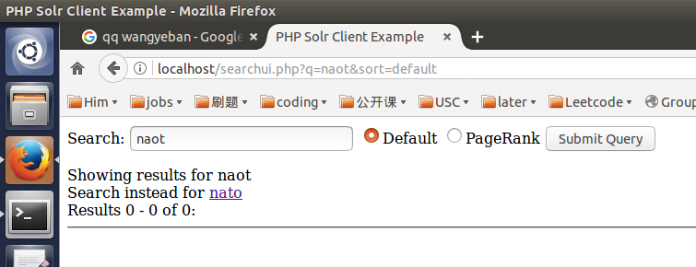

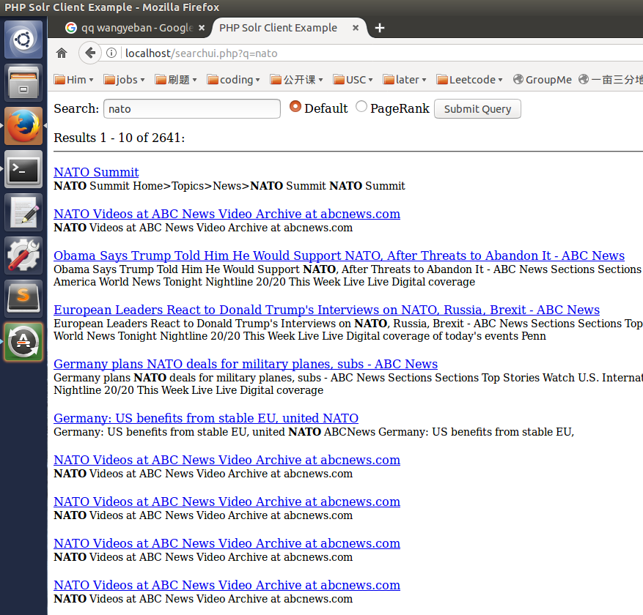

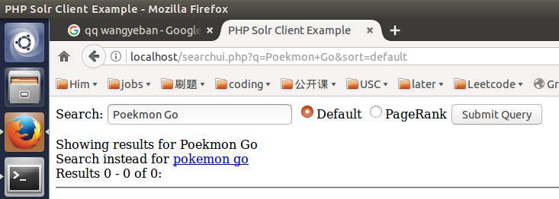

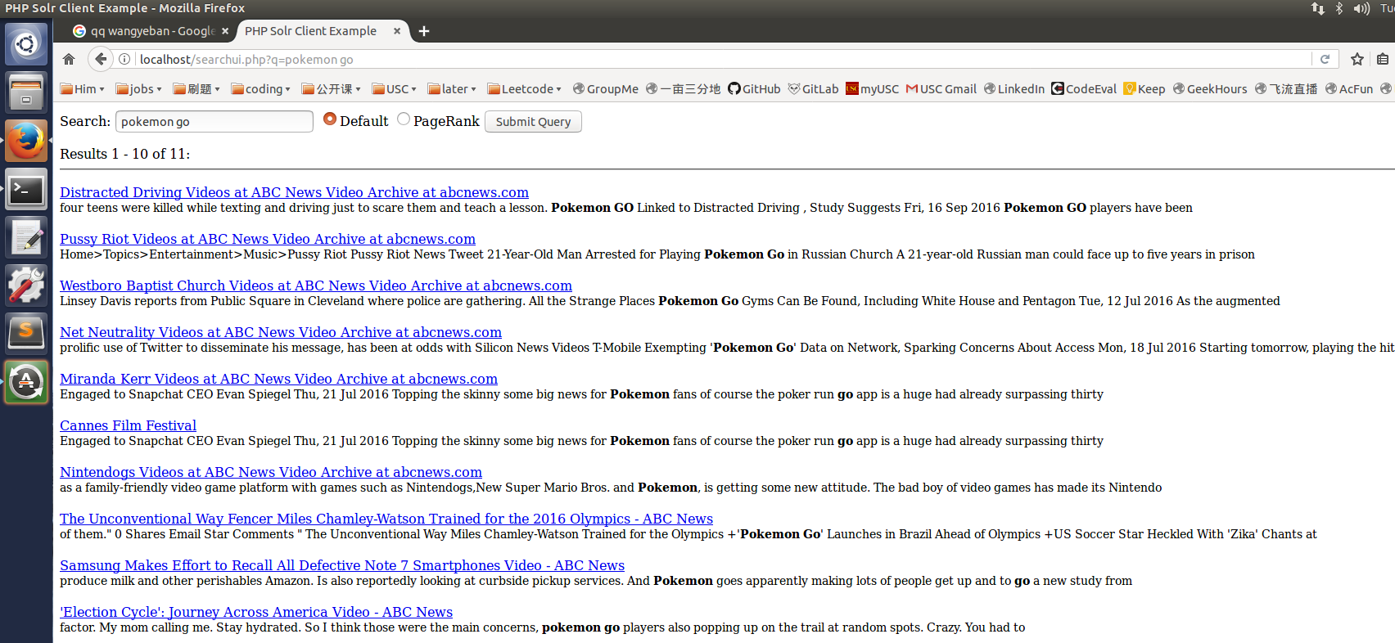

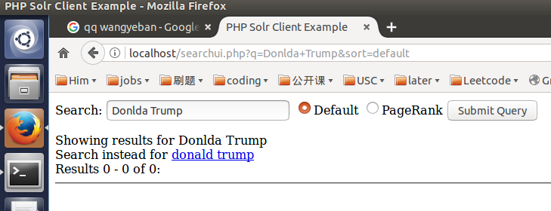

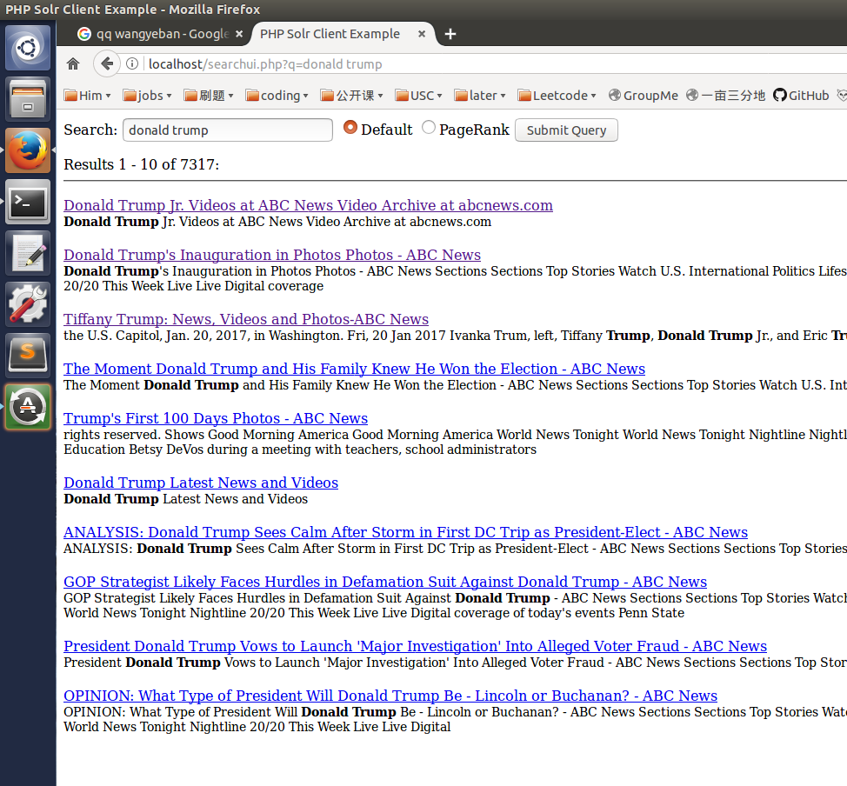

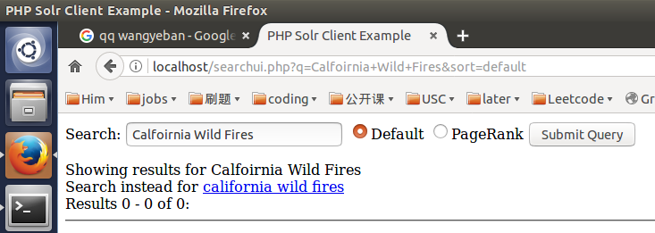

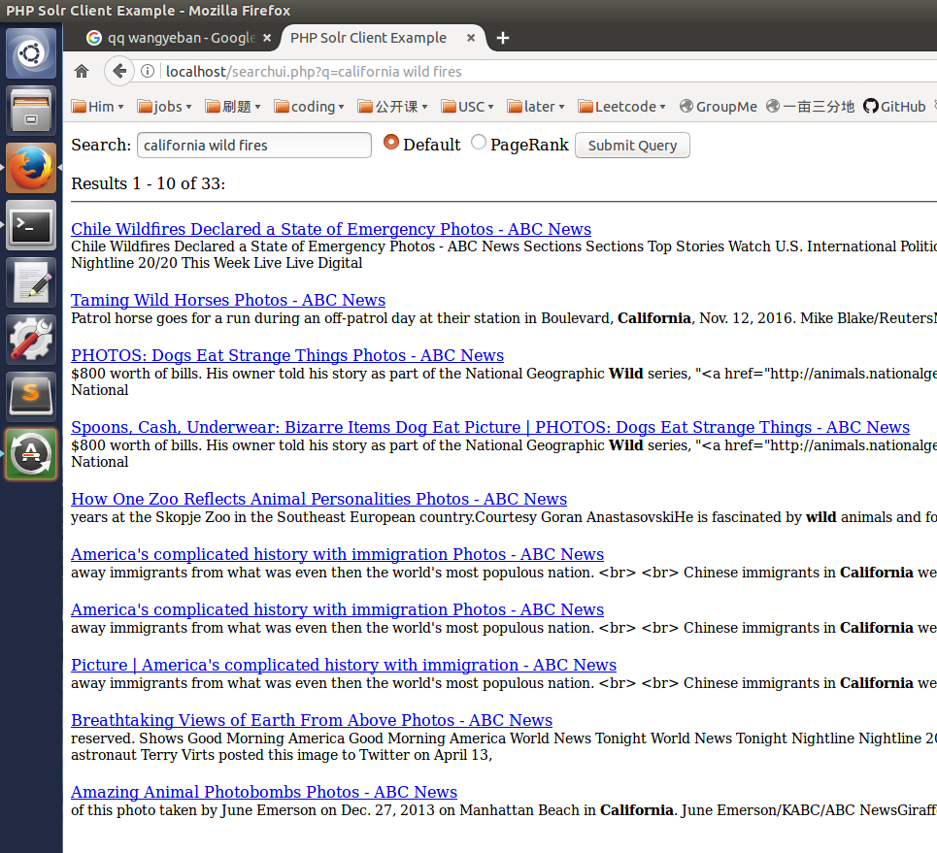

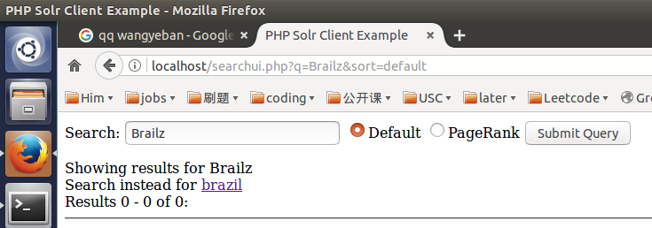

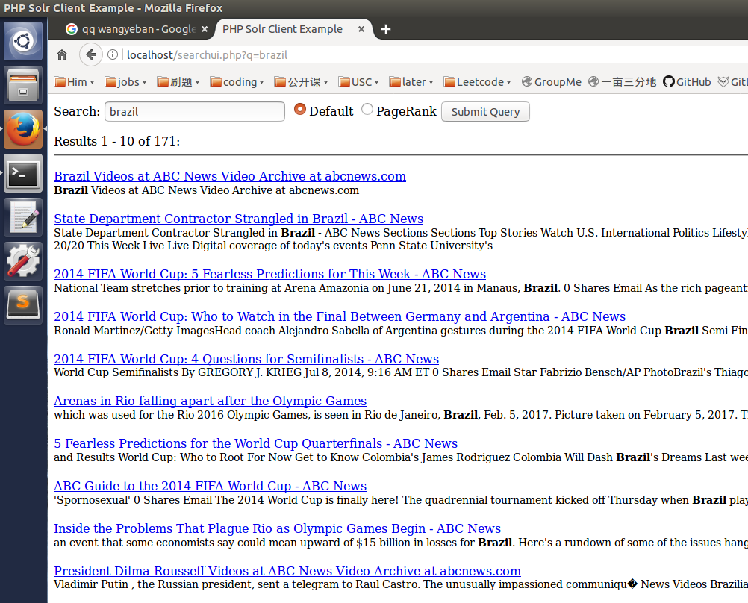

1. Five examples of autocomplete

